COMP259 Lab 03 –Android Activities and Intents
Complete each of the indicated demonstration apps and use them as a basis to complete the Personnel App with the given requirements.

A) Readings and Exercises:
Android Programming Concepts by: Richard Cornez; Trish Cornez, 2015

1) Chapter 3: Activities and Intents
a) | Skim: | Skim the following sections before attempting the exercise:  3.1 Activity Lifecycle  3.2 Starting, Saving, and Restoring an Activity  3.3 Multiple Activities and the Intent Class  3.4 Handling Keyboard Visibility in an Activity  3.5 Passing Data between Activities
b) | Exercises | Follow the steps in these sections to produce and run each sample android applications:  - Lab Example 3-1: Activity Lifecycle Exploration Application  - Lab Example 3-2: Navigating Multiple Screens—Paint Calculator App  - Lab Example 3-3: Automotive Calculator App  Completed Sample code is available on the handout drive:  \\dutch\pccommon\Comp259\Demonstrations\for Lab 03\Chapter03-Converted\Completed Applications\

B) Readings and Exercises:
Beginning Android 4 Application Development by: Wei-Meng Lee, 2012

1) Chapter 2: Activities, Fragments, and Intents
a) | Exercise: | Follow the steps in these sections to produce and run each sample android applications:  - Linking Activities using Intents > Passing Data Using an Intent Object

C) Demonstrations:
Follow the in class Demonstrations for an overview of starting a second activity using an intent from another activity and sending and receiving data between the activities.

COMP259 Lab 03 – Redesign the Automotive Calculator App
Create and demonstrate the following working application to the instructor for marking.

Automotive Calculator App
Modify the an android app from Lab Example 3-3: Automotive Calculator App to move the business logic into the second activity and have the second activity return the results.
Requirements:
Modify the Auto Calculator app as required below:
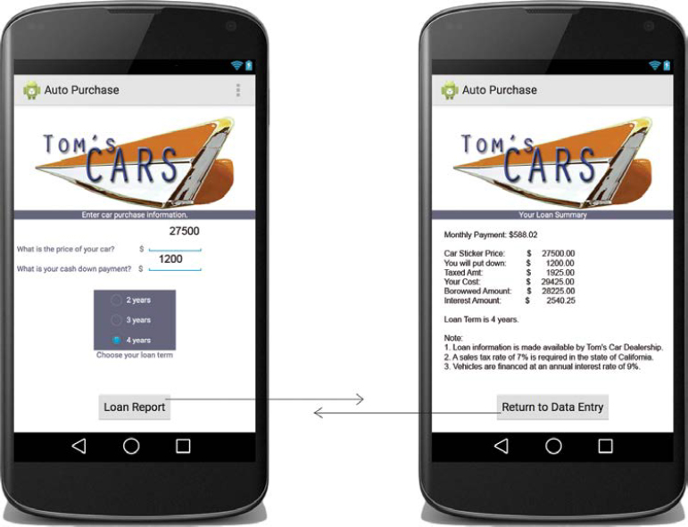
- Move all the processing into the second activity.
- Pass the input values in a bundle and use the StartActivityForResult() method of the first activity to start the second activity.
- The Auto Class should be used in the second activity to calculate and display the required values.
- Return the Total Cost, Borrowed Amount and Interest Amount to the first activity in a bundle object.
- Display the Total Cost, Borrowed Amount and Interest Amount in the first activity layout.
- Add TextViews to the layout of the first activity to display these results.
- Use the onActivityResult() method of the first activity to receive the return values and extract them from the bundle.
(end of lab 03)

